**Waterkinesis Master Guide**

**Goal**

* Let the students have fun with science! We’re combining robots, coding, and EEG to create a project that’s inspiring and hopefully sparks scientific excitement
* With some of the beginning exercises in Cognimates, have the students think about, learn, and discuss AI. Have students interact with AI and take a look at it from a programming standpoint. Spark interesting discussions about AI and how it works, how it was created, how it is used, and how it may evolve.
* Encourage scientific collaboration, exploration and discussion

**Schedule**

**Day 1 (2 hours)**

* **9:30-10 AM:** Introduction
  + Introduce yourselves, maybe play a quick icebreaker game with the students or go around saying things like your favorite ice cream flavor or your favorite pizza topping
* **10-10:15 AM:** Materials presentation
  + Give the children an idea of the types of materials they’ll be working with
* **10:30-10:55 (IN PAIRS, need to use Macs):** Online Worksheets
  + **10 min** Robots portion
    - Share answers on “what would you teach a robot?” question
  + **2.5 min** Reflections
  + **10 min** Muse portion
    - Share answers on “what would you do with direct brain - computer communication?” question (or something along those lines)
  + **2.5 min** Reflections
* **11 AM - 12 PM:** Coding on Cognimates
  + Starter projects (Make Me Happy, Rock Paper Scissors, Change Violet’s Tummy) to introduce AI extensions
  + Create your own project using the extensions (if time)

**Day 2 (2 hours)**

* **9:30 - 9:45 AM:** COUNT OFF IN GROUPS OF 5, FORM TEAM / CHOOSE TEAM NAME / COME UP AND GET MATERIALS
* **9:45 - 11 AM:** Waterkinesis assembly
  + Use 1 pager to explore coding portions
* Waterkinesis exploration
  + Encourage groups to work together to create an even bigger device, complex games, etc
* **11 AM - 12 PM:** GO DEMO / TEST AT POOL
* Ending questions
  + Reflect on the project, discussion on AI

**Waterkinesis Worksheets**

1. Robots portion worksheet
   1. Which of these has a brain: Human, cat, elephant, bird, robot (see how many respond with robot, and what discussions they have if any)
   2. Which is closest to a human: any of the above, see how the students answer and what discussions they have
   3. 2 similarities between humans/robots: observe discussions and encourage students to dig deep and think about both detailed and high-level similarities
   4. How do you think children learn: we teach them, parents teach them, kids go to school, read books, etc. see if any interestingly thought-provoking answers pop up
   5. How do you think robots learn: people program them, models are trained, etc. see if any interesting answers pop up
   6. Do you think you can teach a robot: yes! If any children say no, prompt them why (i.e. only grownups teach robots, robots know everything when they’re made, etc)
   7. If you could teach a robot, what would you teach it: let the children be creative and if giving suggestions, do really broad ones that foster more thought like - what types of skills do people have that robots don’t? What do you want to help robots improve in? Etc so that their imagination is not limited by examples from teachers.
2. Muse portion worksheet
   1. Let's talk about the brain a little bit. Your brain is made up of billions of nerve cells called neurons.
   2. In your brain, these neurons communicate by sending each other signals. These signals are different when you’re asleep or active. EEG is what we use to record brain activity in graphs.
   3. What would you want your brain to say/would it be different from what you can type on a keyboard: observe the range of answers amongst children for the former, the answer should be
   4. What would you want to ask the computer or learn from it: see if kids give broad or specific answers (likely more specific and inspired by the types of interactions they have with computers), or if they come up with anything particularly insightful.

**Ending Questions**

1. Do you think we should continue to train models that recognize things? Why or why not?: Children will answer in a range of things - yes we should because AI can help us solve big problems, maybe we should because AI can be helpful but it can also be dangerous, no we shouldn’t because robots will someday take over the world and hurt us, etc. Encourage discussion amongst groups and if time allows, discuss with the class what the implications of AI may be.
2. Describe the game your group created with the Muse and Wedo sets: Yay, more creativity! We’re really trying to encourage imaginative exploration and innovation, so encourage the students to really collaborate for cool games, work with other groups, and learn/experiment together.
3. Reflections: Wide range of answers is likely - see what the kids really learned and enjoyed :) See also what the kids struggled with (especially during the first wave so that the second wave can be even better)

**Technical Guidelines**

**## Important: Bluetooth is on and Codelab is in https!**

1. Muse
   1. Load the Muse extension at [codelab.cognimates.me](https://codelab.cognimates.me) and make sure Bluetooth is enabled on the laptop.
   2. Select the "connect Muse" block and click the “allow notifications” notification in the upper right corner of your screen [1]. Then, press the power button on your Muse headset - the light on right ear of the headset should be flashing. Pair (connect) the Muse device to your laptop by clicking the correct headset (the last four digits of the headset’s serial number) and pressing the “pair” button on your screen [2].
      1. 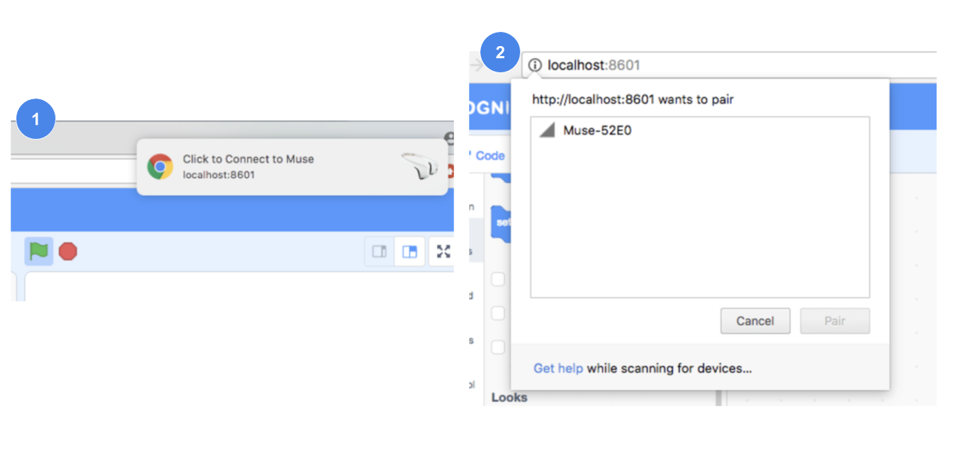
   3. Once the devices are connected, the headset’s light will stop flashing. Test the connection by putting on the headset, waiting for 10 seconds, and clicking the “Get value of” block. Make sure the block gives you a number greater than 0.
   4. Common bugs:
      1. Headset not showing up in detection
         1. Wait a little bit more - sometimes the device takes a while to detect. If you waited more than 1 minute, re-click the connect block and try again. If that doesn’t work, refresh the page and try again. If it still doesn’t detect a minute later, swap headsets with a group that succeeded in connecting to a headset.
         2. Open bluetooth preferences for the laptop and see if the headset appears there.
         3. See if the headset needs more battery, and charge it by connecting it to a laptop if necessary.
      2. Connect block not doing anything even after clicking
         1. Make sure notifications are allowed for the codelab (https://codelab.cognimates.me)
         2. Make sure the codelab has a https URL (http will not allow the bluetooth or Lego Wedo to connect)
2. Wedo
   1. Install the Scratch Device Manager (search Scratch Device Manager on the Mac app store) <https://itunes.apple.com/us/app/scratch-device-manager/id1084869222?mt=12>
   2. Short link for path/file: <http://bit.ly/WedoFolder>
      1. Go to this path: ~/Library/Containers/edu.mit.scratch.devicemanager/Data/Library/Application Support/Scratch Device Manager/  
         Delete the current config.json file and upload the given config.json file that’s uploaded here:

<https://drive.google.com/drive/folders/16fSTXpexxwerE1J1hbohmoMbSc9U-AFW?usp=sharing>. This gives the Cognimates codelab permission to connect to Lego Wedos.

* 1. **Open the Scratch Device Manager FIRST,** then go to codelab (codelab.cognimates.me) and load the Lego Wedo extension. Press the the green button on the Lego Wedo smarthub **FIRST**, then press the connect button on the device manager **SECOND** to connect the two.
     1. 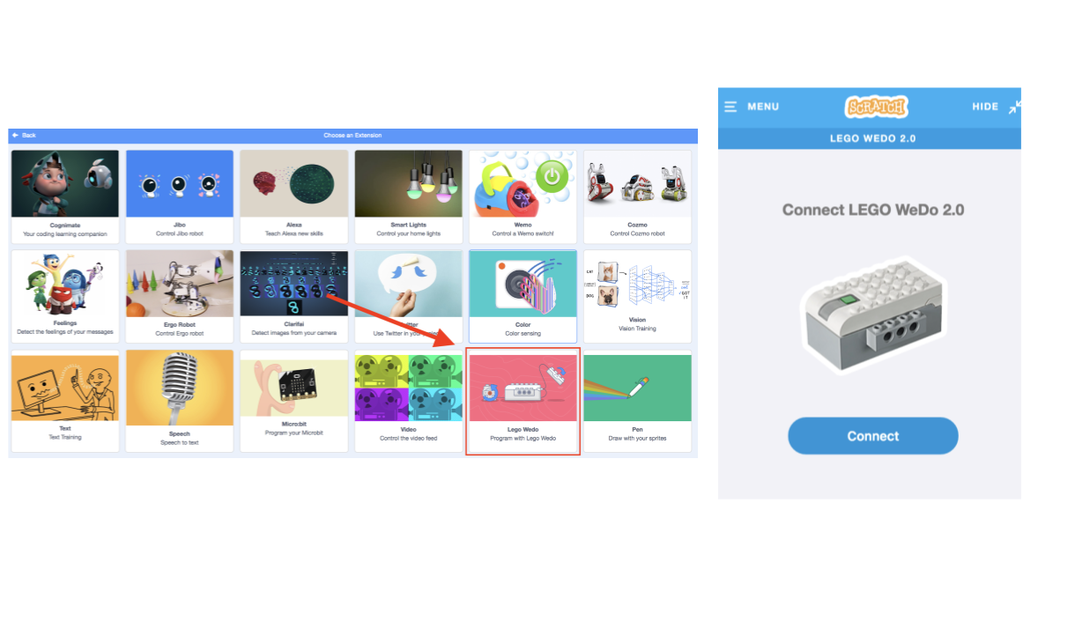
  2. Once the devices are connected, make sure the connection is secured by connecting a motor and clicking any of the blocks that make the motor move or change the color of the smart hub’s light.
  3. Common bugs:
     1. Make sure Bluetooth is on - try restarting Bluetooth if already on
     2. Make sure you’re at <https://codelab.cognimates.me>
     3. Make sure the Scratch Device Manager has the edited config.json file (if unsure, go to the path, open the config.json file, and make sure <https://codelab.cognimates.me> is one of the domains listed - instructions on getting the edited config.json file are above)
     4. Multiple Wedos will make connecting a little difficult - stagger it so that there’s only 1 Wedo trying to connect at once (don’t start the next group’s connection attempts until the previous group has connected for sure)

LINK TO DEMO CODE AND VIDEO: **https://tinyurl.com/waterkinesis-demo**

LINK TO MUSE/WEDO PROJECT: **https://tinyurl.com/waterkinesis-project**

**Cognimates Guidelines**

When getting the kids familiar with the Cognimates platform, we want them to try out some of our starter projects to get familiar with the platform and then create projects themselves (or add their own variations to the starter projects).

1. <https://codelab.cognimates.me> is the codelab, [cognimates.me](http://cognimates.me) is our website with all of our starter projects (which include step-by-step guides that walk you through the project and how it works) under the ‘projects’ tab. Information about each extension is under the ‘extensions’ tab.
2. Have the students pick a start project to work with (Make Me Happy, Rock Paper Scissors, and Change Violet’s Tummy are all good ones to start with) and become familiar with our AI extensions.
3. Have the students create their own projects with the extensions - say ‘let’s make a game!’ or ‘can you create a story that reacts to what you say or give?’ etc.
4. Kids don’t have to use the extensions (if they want to work on normal coding), but encourage them to use the extensions since that is what exposes them to AI and makes it accessible/easily understandable.